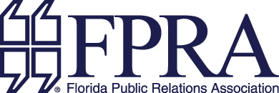

THE JOHN DILLIN AWARD

CALL FOR NOMINATIONS

DEADLINE: April 4, 2022

The John Dillin Professional Award for service to the Florida Public Relations Association has been established as the highest, most prestigious award for the Association. The award honors the spirit
and dedication of FPRA’s first president and founder, Lt. Col. John W. Dillin, and his lifetime of service
to and support of the Association.

The purpose of the annual award is to recognize a FPRA member for his/her outstanding contribution
to the Association and the field of public relations. The award is presented at FPRA’s Annual Conference.

Every professional member of FPRA who meets the award criteria listed below and whose membership is active as of the nomination deadline, is eligible to be nominated, except for the current Executive Committee, Award Selection Committee and State Board of Directors. All bona fide nominations will be voted upon by the FPRA Board of Directors.

AWARD CRITERIA

- Nominee must have been a FPRA member for a minimum of ten years.

- Nominee must have made outstanding and long-standing contributions to FPRA and the public relations profession.

- Nominee does not have to have served as an officer of FPRA.

- Nominations must include a double-spaced, typewritten rationale with specific examples of why the nominee should receive this award.

Send all nominations to the Immediate Past President Alyson Sologaistoa , APR, CPRC,
and FPRA’s State Office via email. Contact information below.

Alyson Sologaistoa, APR, CPRC

FPRA State Office

If you have any questions, please contact FPRA’s Executive Director
Cheray Keyes-Shima, APR, CPRC
941-365-2135

